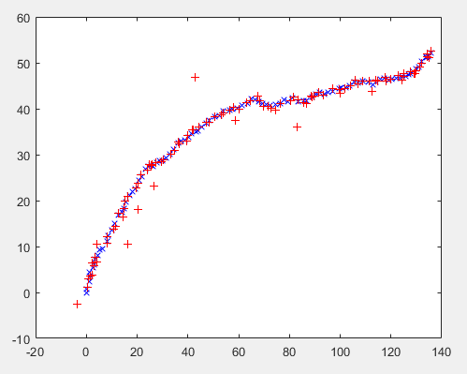

Fig 1: plotting the real(x,y) co-ordinates and noisy(a,b) co-ordinates of target trajectories.

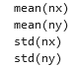 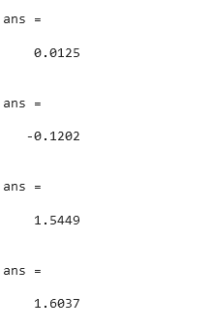

Fig 2: the mean and standard deviation values for real(x,y) co-ordinates of target trajectories.

HISTOGRAM of of x and y plot

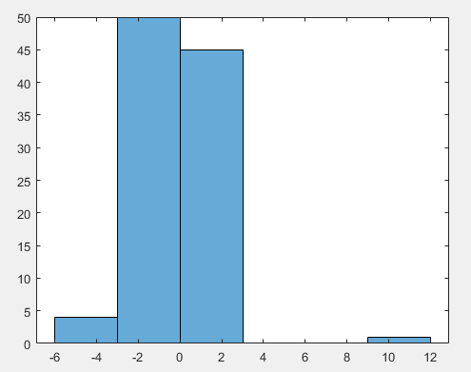

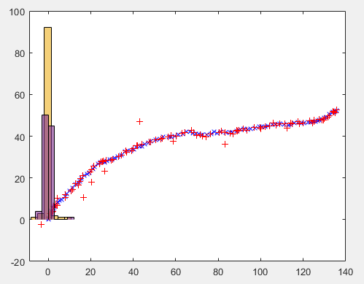

Fig 3: Histogram of real(x,y) co-ord of target trajectories.

Noise Graph

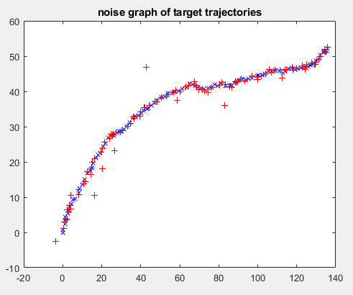

Fig 4: Noise graph of noisy(a,b) co-ord of target trajectories.

When the validation gate is greater than 25.

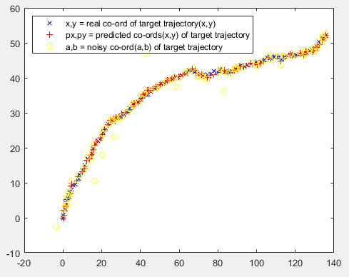

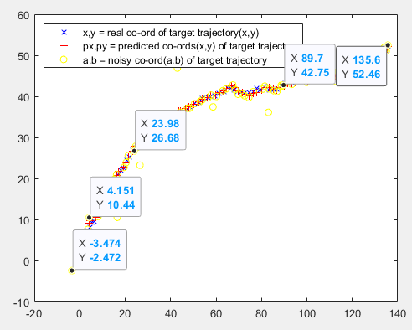

When the validation gate is greater than 40.

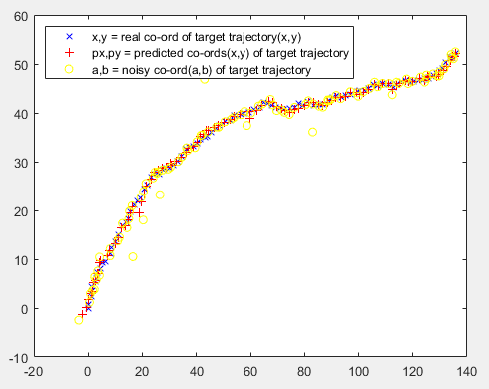

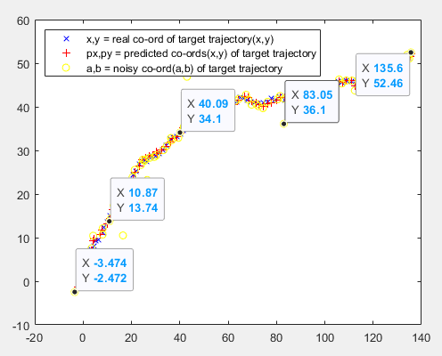

Standard deviation of absolute error of real values (x & y) plotted

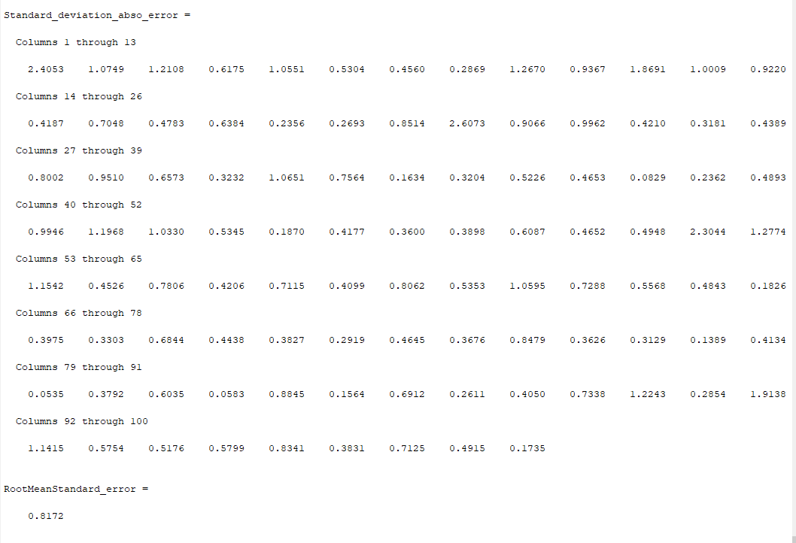

Standard deviation of absolute error of nosiy values (a &b) plotted

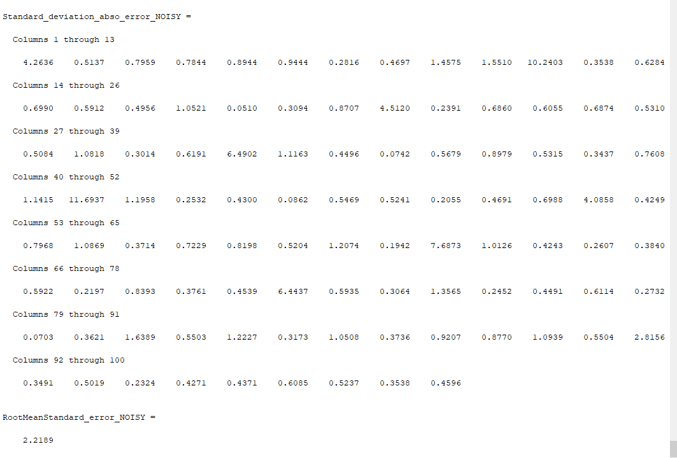

Mean value of x co-ordinates

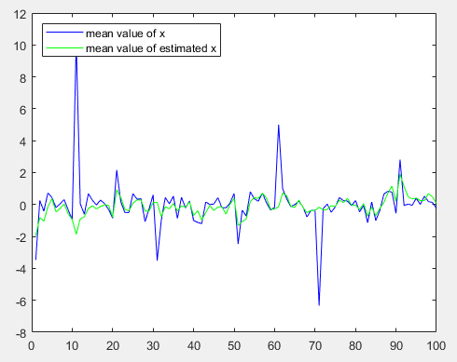

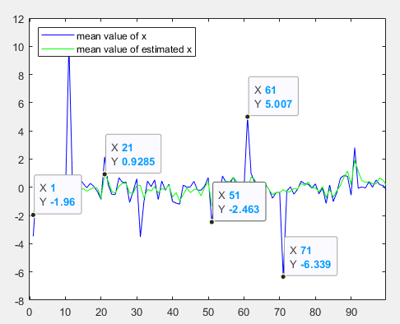

Mean value of y co-ordinates

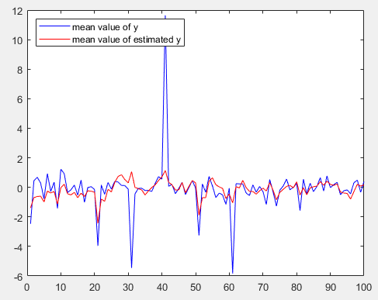

Mean values of Y and estimated Y*were plotted on the graph

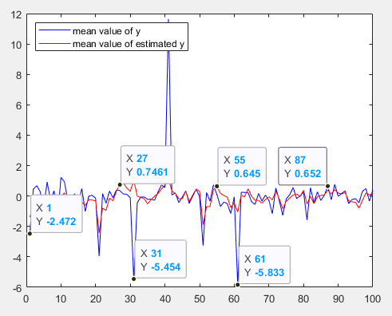

**APPENDICES**

**TASK 3**

**Px values of object tracking**

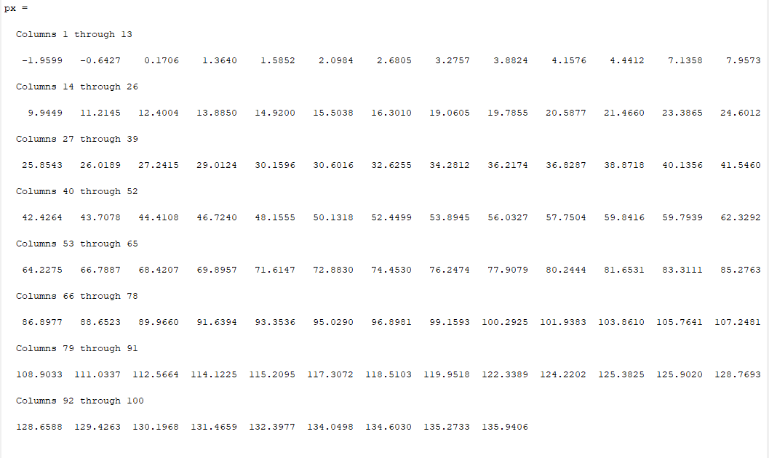

**#Py values of object tracking**

